# CS 255 System Design Document Template

## UML Diagrams

### UML Use Case Diagram

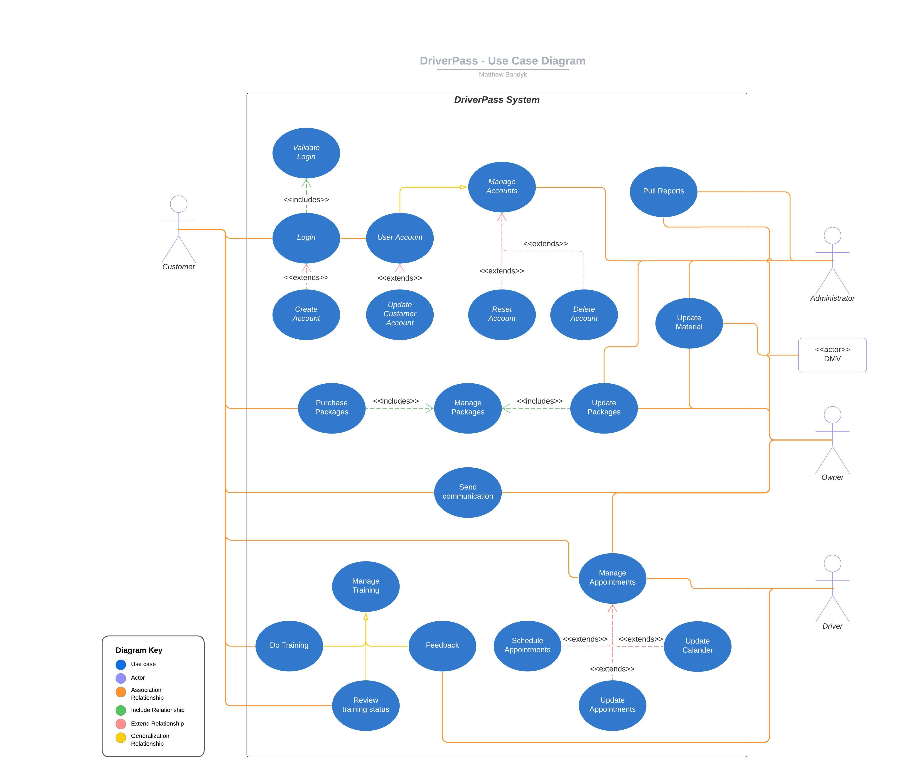

### UML Activity Diagrams

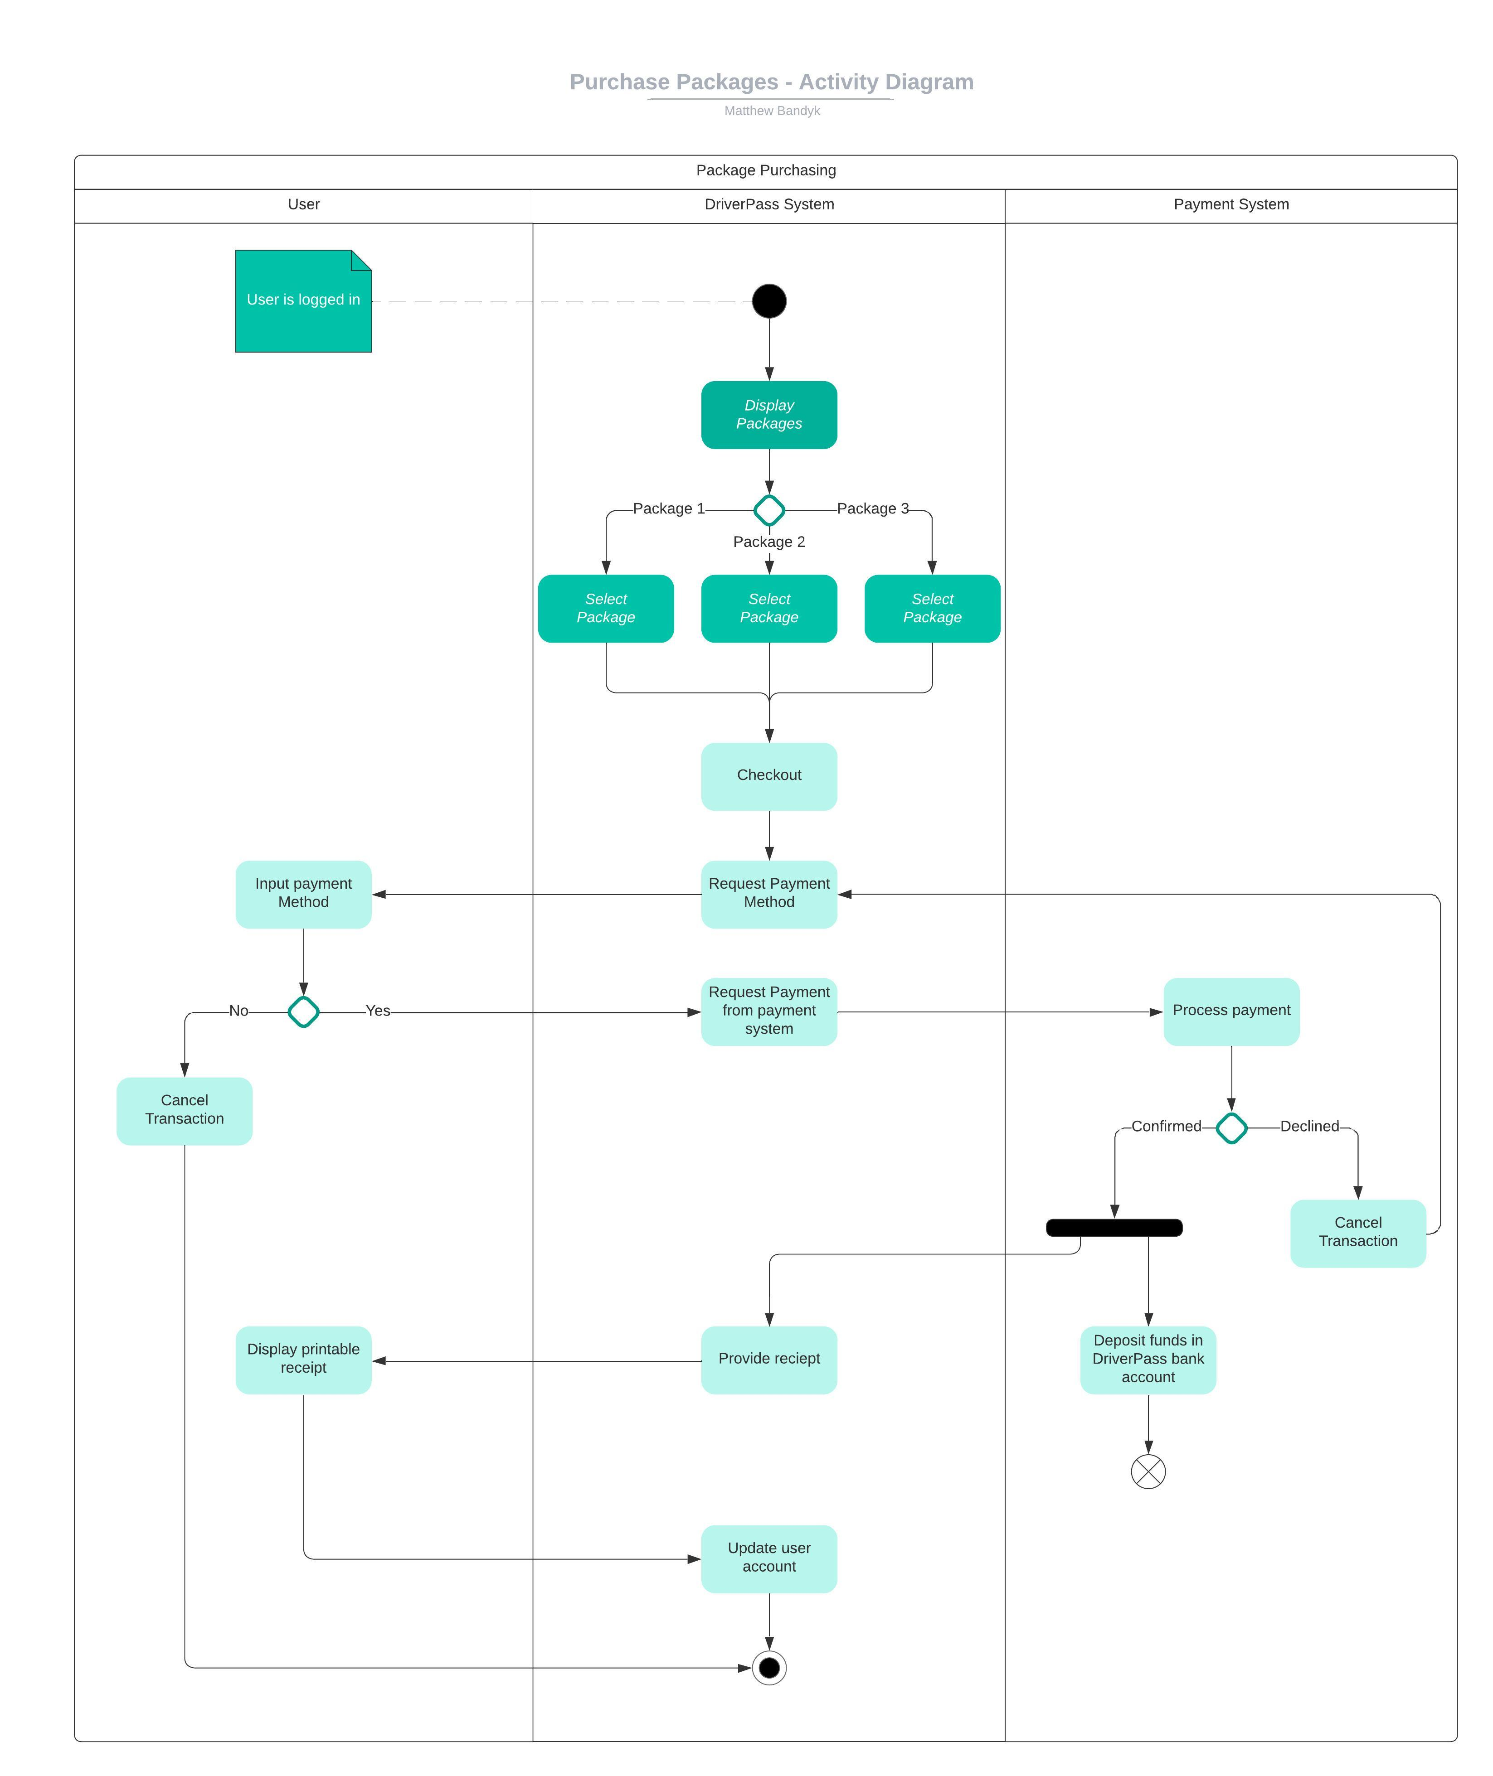

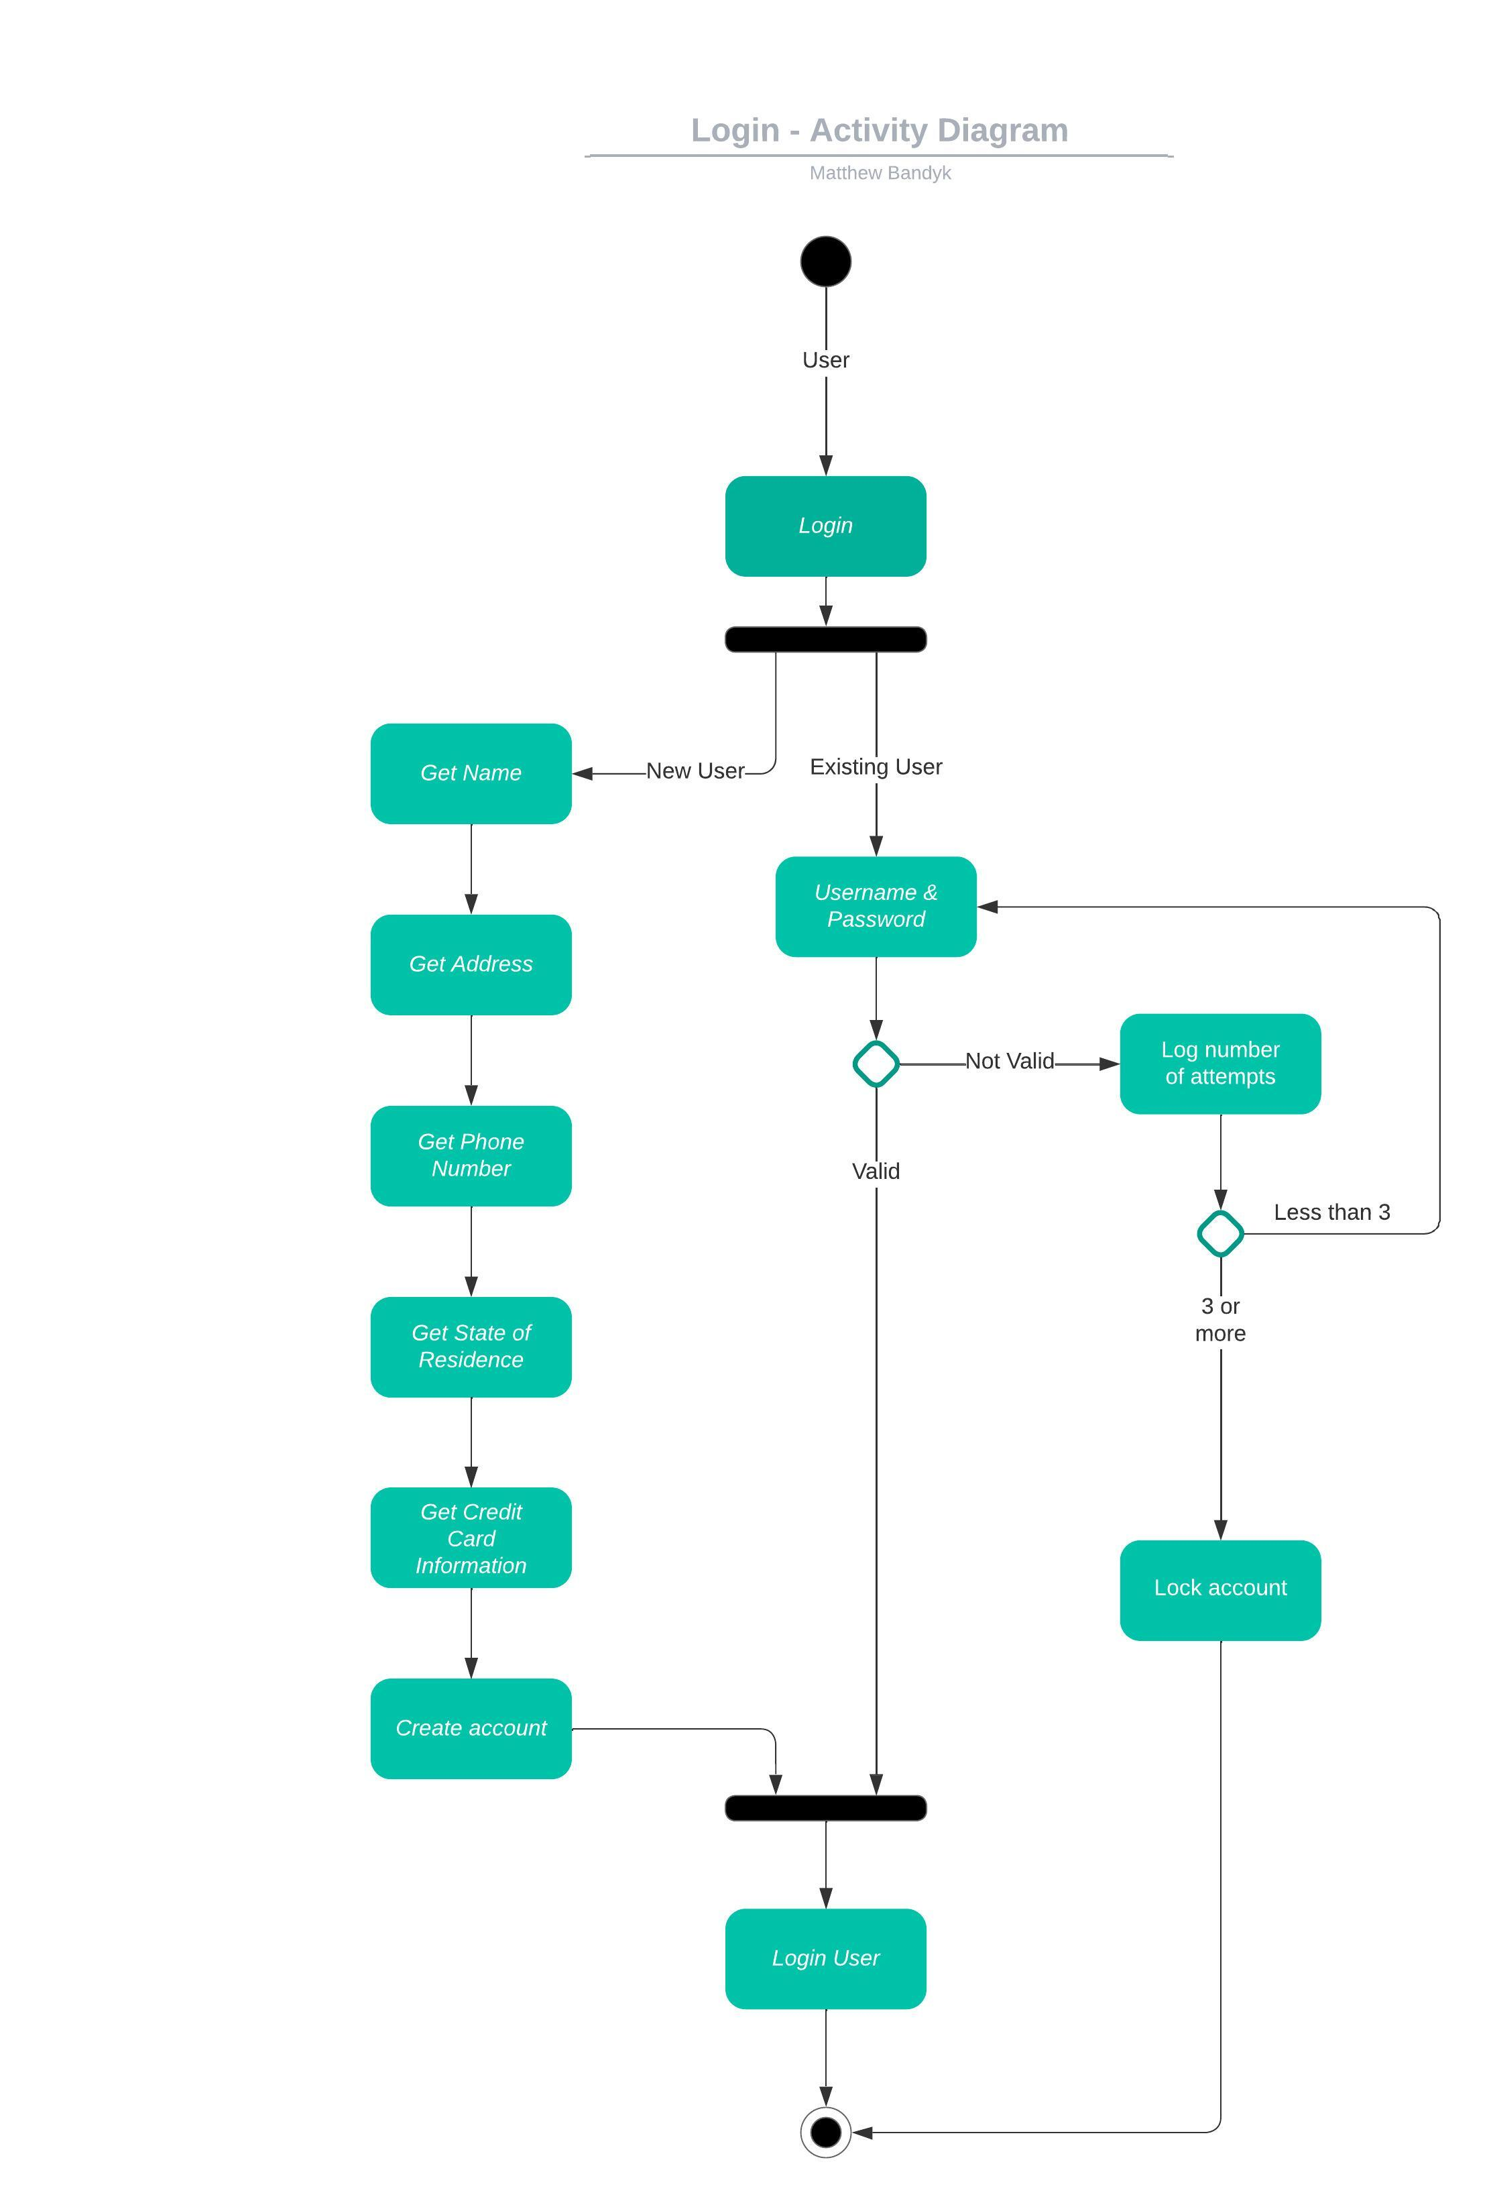

### UML Sequence Diagram

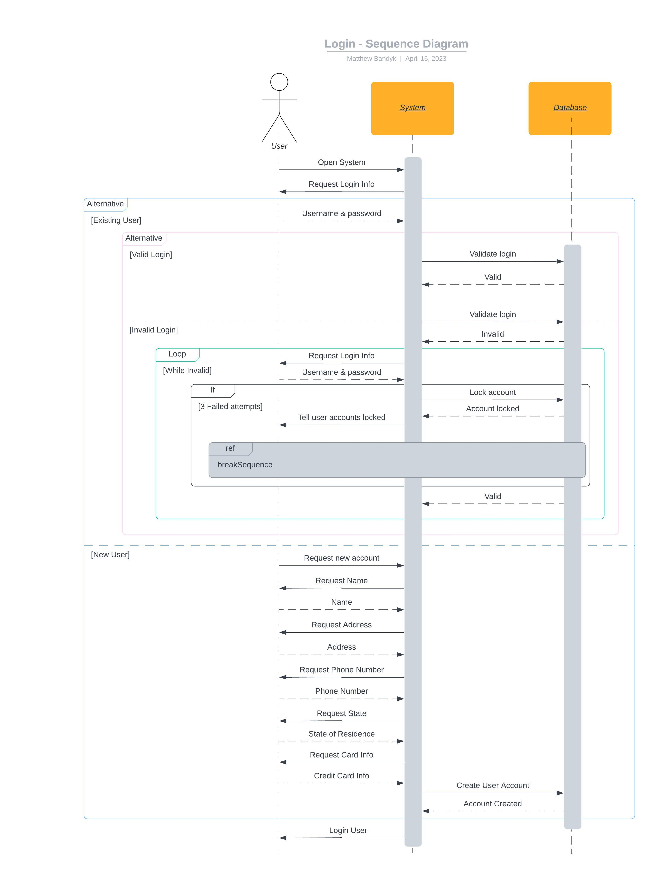

### UML Class Diagram

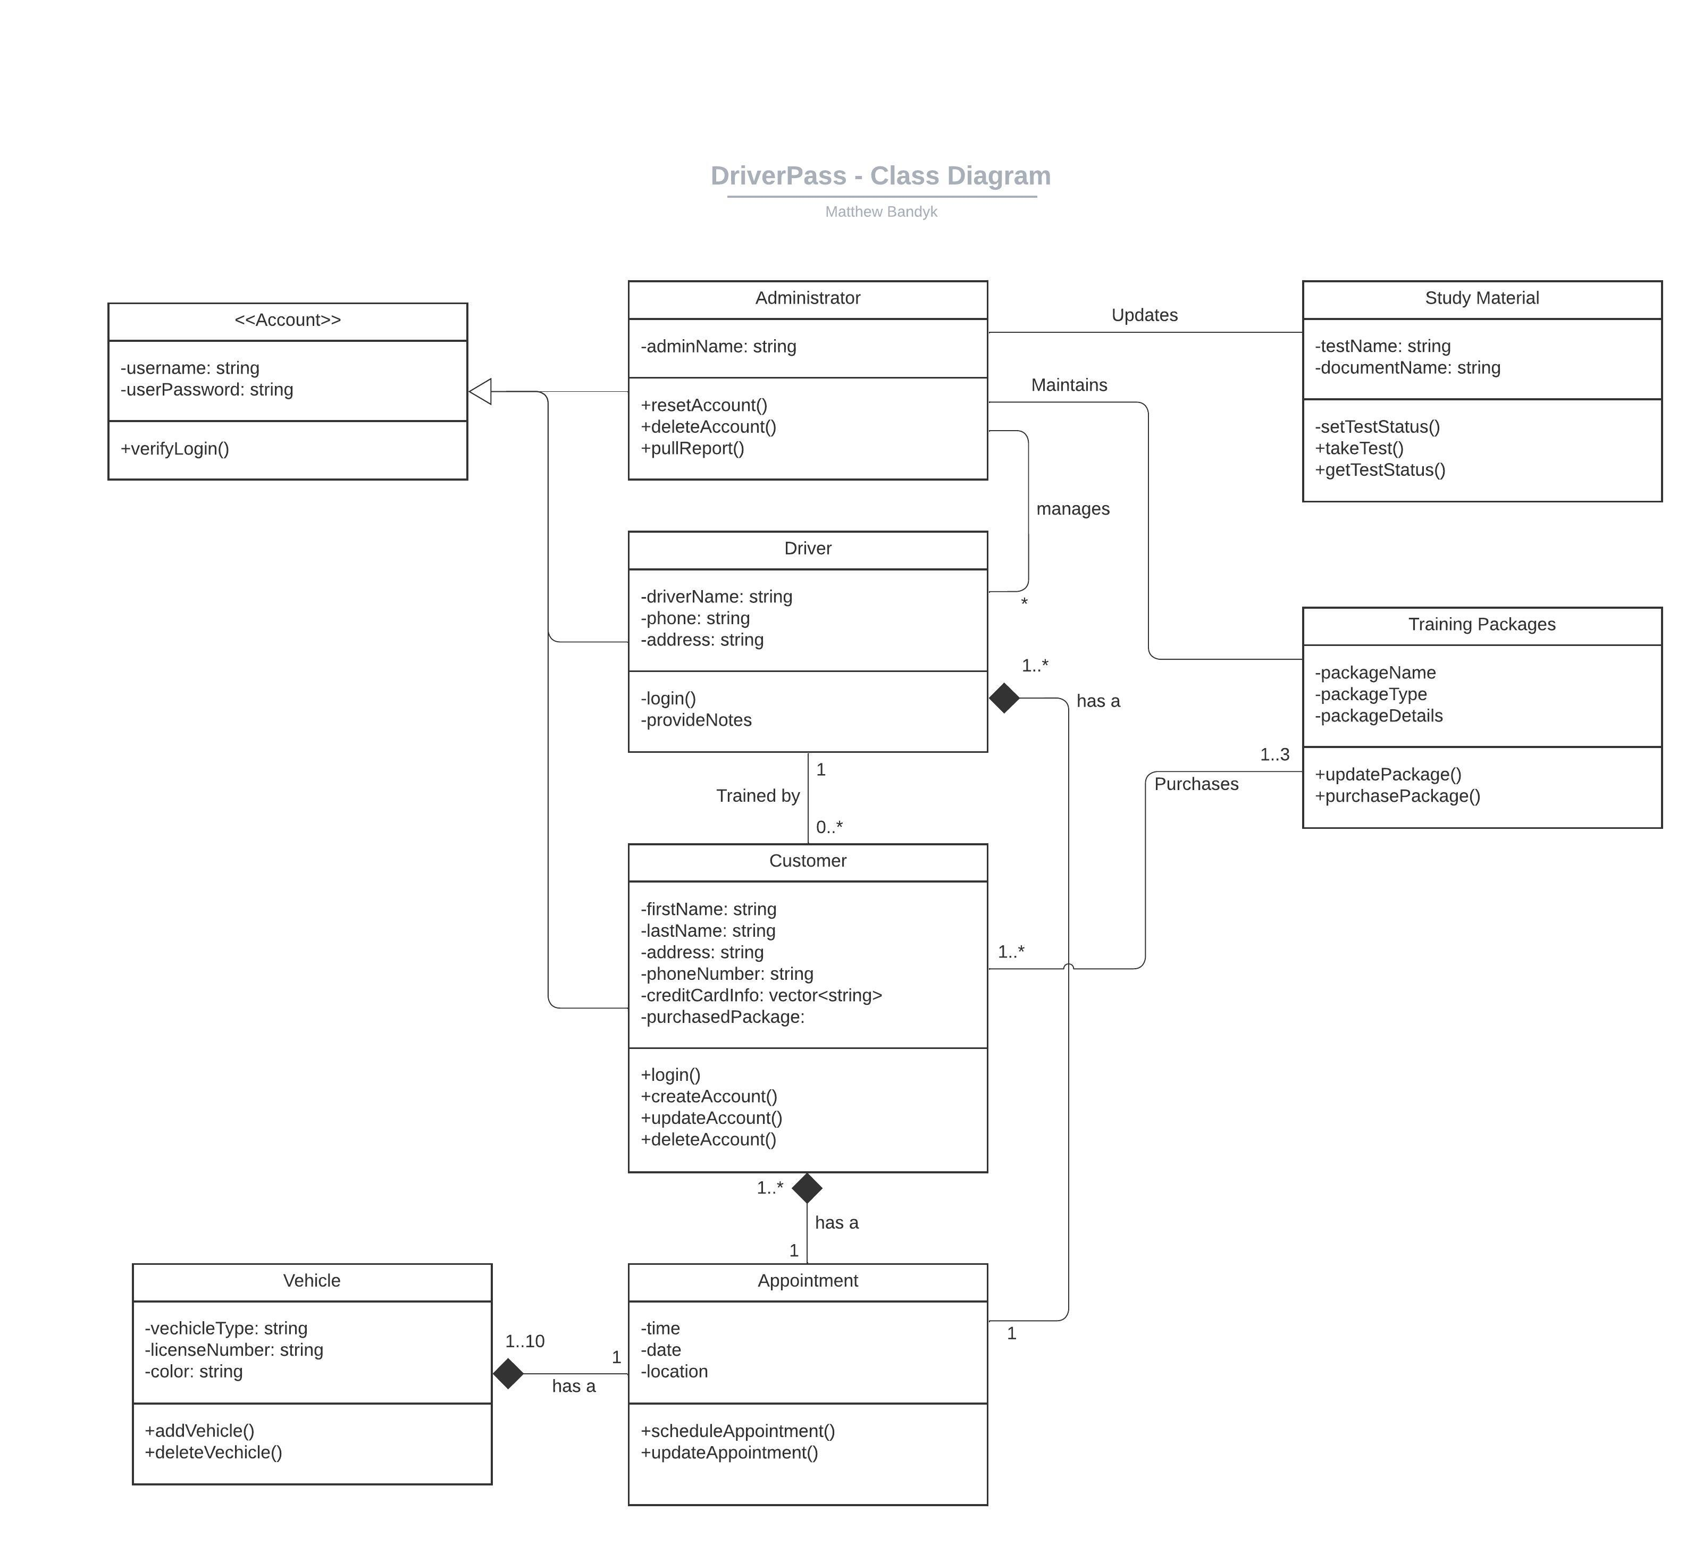

## Technical Requirements

With the design of this system, there are many technical requirements that will need to be addressed which can be broken down into 4 categories. These can be found in the list below:

**Hardware:**

* Computer devices at driver pass to access and maintain the system including:
  + Monitors
  + Keyboards
  + Mouse/s
* Modem with internet access
* Routers
* Business Phones

**Software:**

* IDE applications for the following programming languages
  + Java
  + PHP
  + HTML/CSS
* Internet browser to access the system
* Virus Protection software

**Tools:**

* Cloud hosting service to host the system
* Database to hold the systems data
* REST API system
  + Will handle user roles and account permissions

**Infrastructure:**

* Cars for driving training
* Physical location to house cars
* Rooms at the corporate office for on-site training